***Door bell using push button.***

***Circuit diagram:***

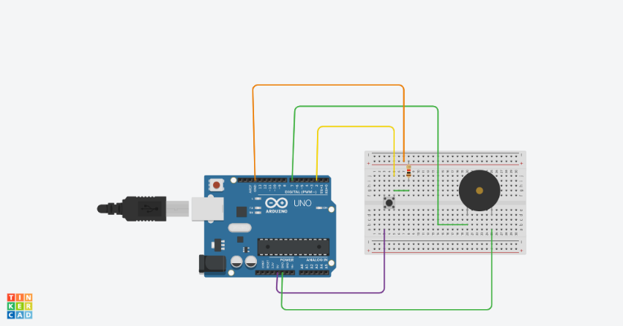

***THEORY:***

***Concept Used:-***

***In this project we have used a buzzer which comes into process when a switch is pressed or a command is given by a switch. One end of switch is connected to v supply and buzzer to 5v supply and second one end is made grounded. This concept can be used in doorbells at many houses .***

***LEARNING AND OBSERVATIOBS:***

***Learnings: -***

* ***How to make use of buzzers using a switch commanding it.***
* ***To do coding on Arduino software as well on tinkercad.***
* ***Compiling and uploading codes done on tinkercad.***
* ***Use of tinkercad for making hardware and software .***
* ***Use of breadboard and to make and execute circuits on it.***

***Observations: -***

* ***Working of a software on tinkercad.***
* ***Ringing of buzzer when switch is pressed.***
* ***Software and hardware used for making circuit.***

***PROBLEMS AND TROUBLESHOOTING:***

* ***Uploading and compiling of codes.***
* ***Checking connections and underlining defective buzzers or switch.***
* ***Checking correct port for software on tinkercad and type of Arduino.***
* ***Correct working of various hardware and software used.***

***Precautions:***

* ***Don’t make loose connections.***
* ***Don’t connect Arduino to the respective pc until the circuit is complete.***
* ***Carefully look on the working of all the devices used while making circuit.***
* ***Carefully look on the working of buzzers and switch.***

***Outcomes:***

* ***The circuit is complete and ringing of buzzer when switch is pressed.***
* ***Can be used also for security purpose at many places.***